**Anette recommends**

Anette loves to read, and Young Adult Literature falls within one of her favourite genres. Are you looking for your next read, but unsure of what book to pick up? Take a look at Anette’s recommendations – you might just find the book for you!

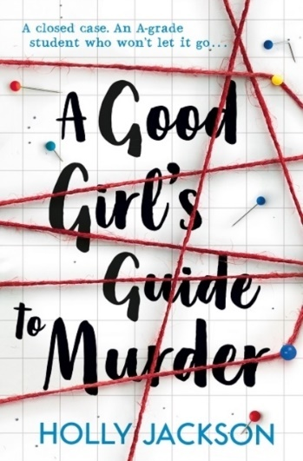**A Good Girl’s Guide to Murder**  
*By Holly Jackson*  
  
**Genre:** YAL, thriller, crime, mystery  
**Pages:** 433  
**First sentence:** “Pip knew where they lived.”  
  
**About the book:**  
Five years ago, the outgoing and popular girl, Andie Bell, was murdered by Sal Singh. The case is closed. Everyone, including the police, agrees on this.

However, Pippa Fitz is not so sure…  
She is a book-smart 17-year old, and she has a hunch that there is something with this case that just doesn’t add up.

Pippa decides to do an extra-credit research report on her suspicions over the summer, and she manages to uncover secrets from all over town.

**Anette’s comments:**

If you’ve ever read Nancy Drew, you will LOVE this thrilling book about Pippa Fitz and her amateur detective work. There are secrets, dangers, and gripping chapters throughout this book.

I read though this book so quickly - that I first thought that I had listened to it as an audiobook.   
However, I actually read it on my kindle.  
  
It is a real page-turner, and you will always wonder what happens next – and then you just HAVE TO read on. The book also has loads of pictures of clues that Pippa finds throughout her research.

I always recommend this book when people ask me what to read next.

This is the first book in a trilogy, but the book itself also works well as a stand-alone book.

Recommended!

**The trilogy:**

The Good Girls Guide to Murder – *Book 1*

Good Girl, Bad Blood – *Book 2*

As Good as Dead – *Book 3*

**The Last Library**  
By Freya Sampson

**Genre:** Fiction, Adult Fiction, Romance  
**Pages:** 302 pages  
**First sentence:** “You can tell a lot about a person from the books they borrow.”

**About the book:**June Jones was supposed to go to university, but then her mom fell ill and died. June closes down and continues to live in her mom’s house for years. She works at the local library and doesn’t have many friends.

Suddenly, the local library is threatened to be closed, and June finds herself slowly climbing out of her shell while she stands up with loyal locals to save the library.

**Anette’s comments:**

This book is sweet and lovely.

I *adore* this book. June Jones is such a sweet protagonist, and the friends she gains throughout this book are some memorable characters. The pensioner, Stanley, must be one of my favourites. I especially love how June uses her knowledge and love of books to reach for her goals.  
  
However, this is not a book I would recommend to someone who haven’t read a lot of books already. This is not a Young Adult Literature book, which means that it is not as action-packed and fast paced as some of the other books in my library.

**Do I recommend it?**

If you have read a lot of books, and if you love libraries, then I recommend this book.

If you want to read about someone who opens up from a silent life, to live fearlessly, then I recommend this book.

If, however, you want an action-packed adventure, then I do not recommend this book.  
This is not a book I would recommend as a first-timer book.

It all comes down to what you are looking to read.

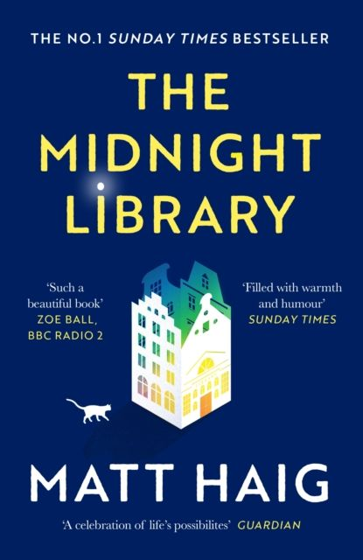**The Midnight Library**  
*By Matt Haig*

**Genre:** Adult Fiction, Fantasy, Mental Health  
**Pages:** 288  
**First sentence:** “Nineteen years before she decided to die…”

**About the book:**Nora Seed is depressed and feels like she has nothing to live for. She ends up taking her own life.  
  
After doing so, she wakes up in a bright library, accompanied by the librarian she used to have in her old elementary school.

She is told that the library’s books are all variations of what her life could have been, if she made a different choice. To experience these versions of her life, she simply has to pick up the book, and open it.

**Anette’s comments:**

The concept of this book is genius. We all wonder, from time to time, how our lives would have been, if we only had made this one other choice instead.

Nora Seed gets to explore loads of different options of what her life could have been. She gets to see herself as a professional swimmer, as a world-famous singer, and as an arctic researcher. All these different versions of her are available for her to experience in the Midnight Library.

The message at the end of the book is also good, and I feel like I’ve learned a thing or two about life through this book.

Recommended!

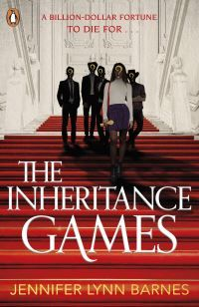**The Inheritance Games**  
*By Jennifer Lynn Barnes*  
  
**Genre:** Mystery, Young Adult Literature, Thriller  
**Pages:** 376  
**First sentence:** “When I was a kid, my mom constantly invented games”  
  
**About the book:**  
Avery Grambs is a high school student who sometimes lives in her car, and sometimes lives with her sister. She does not have a lot of money, but her grades are good – and her plan is to do well enough at school to win a scholarship, and then get away from her hometown.  
  
One day, she is called into the principal’s office, and is met by a handsome billionaire’s grandson, Grayson Hawthorne. Apparently, her name is in the Hawthorne will, and it is required that she is present at the reading of the will.  
  
As Avery arrives at the biggest mansion in America, she is surrounded by riddles, codes and puzzles.  
Who are the Hawthorne’s? Why is Avery in their will? And what secrets can she uncover?

**Anette’s comments:**  
This read is like an “Escape the Room” experience in book-form. There are codes and riddles all over the place, and the characters are intriguing. You will keep turning the pages, wondering what you will uncover next. A true page-turner!

As Avery gets to know the four Hawthorne-brothers: Nash, Grayson, Jameson and Alexander – she also gets closer to the truth: Why was her name in the will?

Recommended!

**The trilogy:**

The Inheritance Games – *book 1*

The Hawthorne Legacy – *book 2*

The Final Gambit – *book 3*